Western User Group: July 31, 2012

Rochester Regional Library Council
390 Packett’s Landing, Fairport, NY (11am – 4pm)

Agenda for Attendees

10:30am-11:00am: Registration & Coffee
11:00am-11:45pm: Meet, Greet, Overview & Goals
11:45am-12:00pm: Preview of ILLiad upgrades
12:00pm-12:30pm: Article Exchange & Intro to Addons
12:30pm-1:15pm: Lunch
1:15pm-2:15pm: Print Template Troubleshooting
2:15pm-2:30pm: Break
2:30pm-3:30pm: Roundtable discussions
3:30pm-4pm: Wrap up

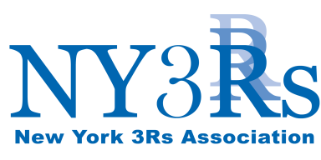
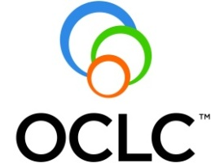
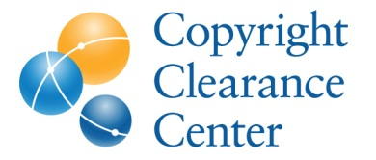
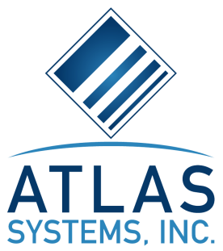
Made possible by our Strategic Partners

