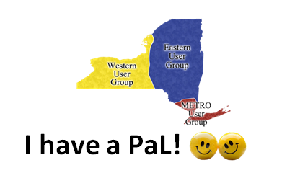

Library Partner Report
The IDS Project Library Partner Program is designed to facilitate networking and local collaborations with IDS Members within your Region. Fill out the following template to easily share your library partner experiences!
Libraries: __________________________________________________________________________________
_______________________________________________________________________________________________

Getting to Know another Library’s ILL Department: What is one thing you learned about your library partner during introductions.

Paired to Share!
Describe one idea and one issue you discussed with your library partner. How did you implement this idea, if at all? What was the outcome of troubleshooting your issue? Were any improvements made to your department as a result of these discussions?

Venture out into the World!
Describe your visit! Include any pictures you took, ideas you shared or brought back to your own library. Share one or two things you learned about your partner’s library (not necessarily just ILL department) that you didn’t know before!

